CDR Report

Authors:
Nikolai DiLullo, Alexandra Friebolin, Alexia Hnatowicz, Jacob Morrissette, Joe Sedutto

Professor McInnis and Professor Guo
EG498 Capstone Design I
Fall 2025

Table of Contents
Project Description 4
Customer Requirements 4
Solution Description 4
ConOps Summary 5
Subsystem: Structural - Mechanical 5
System Requirements 5
System Design 7
Trade Studies 7
Proof of Concept / Feasibility Testing 9
List of Applicable Standards 9
Analysis 10
Component Design Detail 11
Subsystem: Structural – Thermo-Fluid 15
System Requirements 15
System Design 15
Trade Studies 15
Proof of concept or feasibility testing 15
List of Applicable Standards 15
Analysis 15
Component Design Detail 15
Subsystem: Safety 15
System Requirements 16
System Design 17
List of Applicable Standards 17
Analysis 17
Component Design Detail 18
Interface With Structural and Thermo-Fluid Subsystems: Insulation and Safe-Touch Temperature 18
Interface With Electrical Components: Current Transformer for Electrical Protection 18
Interface With Control System 19
Subsystem: Electrical Components 19
System Requirements 19
System Design 20
Trade Studies 20
Proof of concept or feasibility testing 21
List of Applicable Standards 21
IPC-2152 21
Analysis 21
Component Design Detail 22
Subsystem: Control System 24
System Requirements 24
System Design 26
Trade Studies 26
Screen Selection 26
State Machine 30
Proof of concept or feasibility testing 33
List of Applicable Standards 33
Analysis 33
Component Design Detail 33
Intercommunications 34
Sensors and Inputs 34
Drivers and Outputs 34
Risks and Mitigation 35
Verification Matrix 36
Design Considerations 36
Global Considerations 36
Cultural and Social Considerations 37
Public Health, Safety, and Welfare Considerations 37
Economic Considerations 37
Environmental Considerations 37
Open Design Issues 37
Budget 37
Conclusion 38
References 38

List of Tables
Table 2.1: Structural Requirements
Table 2.2: 5052 H32 0.063” Aluminum Material Properties (Send-Cut- Send)
Table 2.3: Insulation Trade Studies
Table 2.4: Current Best Estimate for Structural Weight
Table 3.1: Thermo-Fluid Requirements
Table 3.2: Cooling Trade Studies
Table 4.1: Internal Safety Requirements
Table 4.2: External Safety & User-Contact Requirements
Table 4.3: Operation & Fault-Response Requirements
Table 4.4: Safe-State Requirements
Table 5.1: Electrical Components Requirements
Table 5.2: Heating Trade Study
Table 6.1: Customer/System Requirements
Table 6.2: Control System Requirements (Part A)
Table 6.3: Control System Requirements (Part B)
Table 6.4: Screen Selection Trade Study
Table 6.5: MCU Trade Study (Part A)
Table 6.6: MCU Trade Study (Part B)
Table 8.1: Verification Matrix
Table 11.1: Itemized Purchased Budget
Table 11.2: Overall Budget

List of Figures
Figure 2.1: Aluminum Handle Prototype
Figure 2.2: Chamber External Assembly
Figure 2.3: Frame Assembly Views
Figure 2.4: 8 Panel Design
Figure 2.5: PCB Testing Chamber & Support
Figure 2.6: Airflow Management Compartment
Figure 2.7: HMI Display Mount
Figure 2.8: Chamber Door Handle Design
Figure 4.1: Current Transformer
Figure 5.1: Electrical Flowchart
Figure 5.2: Interconnect board
Figure 5.3: Current PCB Layout
Figure 6.1: CrowPanel 7.0 ESP32
Figure 6.2: Thermocline GUI Prototype, LVGL block
Figure 6.3: Thermocline State Machine
Figure 6.4: Overview of Task State Management
Figure 6.5: Example JSON Packet
Figure 6.6: Example of electrical arcing across relay contacts Source: Wikipedia
Figure 7.1: Risk Tables
Figure 7.2: Risk Matrix

Project Description

Customer Requirements
The customer requires the development of a controlled temperature chamber for evaluating the performance of electronic components under varying thermal conditions. The chamber must accommodate a 12″×12″ printed circuit board and incorporate a sealed port for routing external electrical connections needed for stimulus and measurement. It must be constructed with appropriate insulation to minimize thermal losses and equipped with the ability to heat and cool the internal volume across the commercial operating range of 0°C to 70°C while maintaining the temperature within ±3°C of the setpoint. In addition, the system must include internal temperature monitoring and provide recorded data. These capabilities are necessary to support reliable and repeatable component testing as specified by the project sponsor, Dr. Monk.

Solution Description
The solution will be in the form of a labratory appliance. It will be installed on a table no deeper than 30” to accommodate labratory table depth. It will be no wider than 30” to take up excess space. The system will run indoors, use standard AC wall power (120V, 60HZ). Will not require external ducting or pumbing. And will not require (but may optionally include) external, remote or computer control.

ConOps Summary
The Concept of Operations (ConOps) outlines the intended function, environment, and operational behavior of the thermally controlled PCB testing chamber. The system is a tabletop, insulated chamber designed to accommodate 12″×12″ PCBs and regulate internal temperature within the commercial range of 0–70°C while maintaining ±3°C accuracy. It operates in an indoor laboratory environment with stable power, proper ventilation, and access to PC-based data logging. The chamber supports multiple operating modes—including Shutdown, Standby, Start, and Safe states—and allows users to insert test boards, connect measurement cables, and monitor temperature performance locally or remotely. The ConOps identifies primary stakeholders such as engineers, maintenance personnel, faculty, and material suppliers, all of whom contribute to system design, operation, and lifecycle support. It also evaluates operational impacts, including thermal hazards, electrical safety concerns, ventilation requirements, spatial constraints, and data management needs. Finally, the ConOps provides a structured risk assessment addressing potential failures in design, fabrication, operation, and maintenance, assigning likelihood and consequence values to prioritize mitigation efforts. Collectively, the ConOps establishes a clear operational framework that informs system requirements, guides engineering decisions, and ensures safe, reliable, and traceable thermal testing of electronic components.

Subsystem: Structural - Mechanical

System Requirements
The structural subsystem requirements are strict guidelines for the final system that must be adhered to for a successful project. The product must satisfy both customer and team design specifications – arising from design considerations, project timelines, available resources, financial budgets, or product needs. The following database in Table 2.1 represents the team’s structural subsystem requirements as of the Preliminary Design Review, which specifics are subject to change later depending on customer modifications, team discussions, or design updates from testing.
Number | Requirement | Performance | Margin | Verification
STR-01 | The system shall have external base dimensions of no more than 30x30 inches. | 30x30 in | -2x2 in | Inspection
STR-02 | The system shall have internal base dimensions of no less than 12x12 inches. | 12x12 in | +2x2 in | Inspection
STR-03 | The chamber opening(s) shall include proper thermal sealing according to ASTM F1886 | Complies | N/A | Inspection
STR-04 | The internal thermal control components shall include proper thermal sealing according to ASTM C633-01. | Complies | N/A | Inspection
Table 2.1 Structural Requirements
The following notes provide further detail on each requirement:
STR-01 is a customer-provided requirement. Considering the product’s end-usage will be a local operating table-top system, it should be able to fit conveniently on most SNHU tables, desks, and benches without protruding from their edge; having a requirement that limits the external base dimensions of the system will satisfy the customer’s desire to have an easily accessible, movable, and safe system. The margin of -2x2 inches, although relatively small, can be modified with both a customer- and team-agreement since the lower bound is more flexible, as it constricts dimensions below 30x30 inches. Although smaller dimensions will constrict internal area and component-arrangements, this design decision will most likely save costs, material, and fabrication time. The final system’s external base dimensions shall be measured and inspected to verify if the requirement is met.
STR-02 is also a customer-provided requirement. In order for the final product to evaluate PCB performance, it must first adequately fit the PCB without mechanical/electrical damage or complicated installation. Thus, the system should incorporate an internal floor space of at least 12x12 inches. Tighter areas could satisfy smaller PCBs, but would fail at incorporating the largest. Designing an area larger than this provides room for possible extruding components from the PCB, as the “tester” dimensional specifications are contemporarily unknown at the time of this design report. The margin for this requirement of +2x2 inches is stricter than STR-01—where the team aims closer to the performance value, as larger than 12x12 inches could reduce insulation and prompt larger external dimensions.
STR-03 is a team-determined requirement, derived from Design Requirement 1.2: Included Insulation. Since the system will have external wiring for its power supply and connections to the tested-PCB, structural openings are inevitable. These ports must thus be properly sealed in order to still satisfy being insulated and safe. ASTM F1886 outlines a visual inspection test procedure for seal integrity to ensure the system complies (1).
STR-04 is also a team-determined requirement derived from several of the system’s safety design requirements. The internal components are concerning the thermal-fluid cooling system, resistive heating process, electronic controls, and other mechanical elements. ASTM C633-01 is a “Standard Test Method for Adhesion or Cohesion Strength of Thermal Spray Coatings”, which can be used to determine if the requirement is met (2).

System Design

Trade Studies
The system design and subsystem design requirements are holistic enough to outline important dimensional, functional, operational, manufacturing process, budget, and resource constraint details. However, these regard not the system in its entirety nor account for every project detail. Therefore, numerous trade studies are carried out with the team and stakeholders—if applicable— to further progress design specifications. These trade studies can be simple through small verbal discussions, or highly detailed spanning weeks of research, testing, and analysis to provide insights into the design. The trade study determining the primary material for the system’s external framework, internal support, and housing compartments was completed through a team discussion. This study was finalized early in the design process as the team understood its implications would drive several other design considerations such as insulation, fixture attachments and joint connections, and the arrangement of other components and subsystems. Ultimately, using a 0.063” 5052 H32 Aluminum-based alloy would provide the greatest success for the final product. Its critical material property specifications are outlined in Table 2.2 below (3).

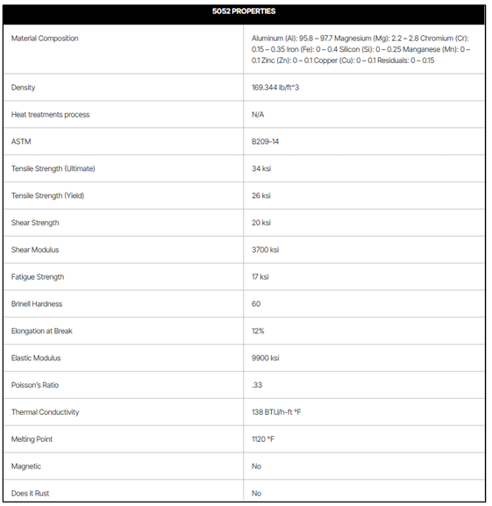Table 2.2: 5052 H32 0.063" Aluminum Material Properties (Send-Cut-Send)
Through numerous discussions, this Aluminum alloy beat several other material candidates such as Carbon-Steel, Titanium alloys, glass composites, and heavy-duty plastics. The team found its general low-costs – in manufacturability, installation and repairability – to work within the given budget constraints. Its lightweight property promotes greater usability during operation and maintenance procedures, while contributing less to mechanical stress/strain for load-bearing structures. The Aluminum would also be able to withstand the mechanical and thermal conditions within the system, making it suitable for the system’s designated environmental condition range. Most prominently, Send-Cut-Send is a well-reputable manufacturer, able to fabricate the designed pieces, provide consistent and strong customer support, hold efficient lead times, perform solid quality inspections, and provide precise and highly reliable parts. Outsourcing these pieces pre-cut and bent is more feasible and cost-efficient than performing these operations in-house with parts sourced elsewhere. Moreover, for the structural subsystem, the only heavily analyzed trade study was in regard to the use of insulation material. This comparisons between several known candidates are outlined in Table 2.3.
 | Fiberglass | Polyurethane Foam | Polystyrene | Silica Aerogel
Thermal Conductivity $\left(\frac{W}{m⋅K}\right)$ | 0.032-0.036 | 0.02-0.03 | 0.025-0.04 | 0.0032-0.015
Nominal Thickness (in) | 6-12 | 1.18 | 3 | 0.2-0.4
Malleability | Most malleable | Malleable depending on type | Malleable when molten | Not malleable
Cost | $1.00-4.50/$ft^{2}$ | $0.50-4.50$ft^{2}$ | $1.00-4.50$ft^{2}$ | $10,000$ft^{3}$
Table 2.3: Insulation Trade Studies
These categories shown on the left-hand side of the table were chosen due to being ranked as highly impactful to the success of the insulation itself along with the final product. In conducting a thorough analysis, fiberglass insulation was seen as superior and would contribute to the greatest success for the overall system. Although out of the most accessible and well-known types of insulation studied it had one of the highest thermal conductivities, this value was sufficient enough to properly insulate the system/components – where the other categories increased its worth. Having a large nominal size would fit well for the system the team is designing given the large amounts of empty volume needed to be filled with insulation; this process would be simpler with how fiberglass insulation is manufactured and installed. Similarly, its higher malleability over the other candidates would simplify the installation, maintenance, or “plugging” processes, especially in smaller ports and non-uniform spaces. Lastly, being widely available and simpler to manufacture decreases its cost, reducing possible financial burdens on the team and opening room for other purchases throughout the project. Strategically weighing these four categories convinced the team to use fiberglass insulation for producing a highly effective thermally-sealing structure to the system.

Proof of Concept / Feasibility Testing
Early in the team’s research phase, the system’s structure was identified as a crucial aspect to not only the final project’s success, but an important step in conducting trade studies, developing design models, building prototypes, and optimizing subsystems. Therefore, it was important to analyze the structural subsystem and determine an appropriate constituent with significant risk or room for improvement. Since creating numerous panels and other supporting pieces with laser-cut sheet metal was under heavy consideration, the team decided to test the supply chain capability of Send-Cut-Send – given this manufacturer’s higher precision, efficiency, and ease-of-design/fabrication. By designing a simple piece – yet one that would test many of their capabilities, the team could determine whether this manufacturer was feasible down the line of the project. For this test, the chamber door handle was designed with 3D-modeling software, ordered through Send-Cut-Send, fabricated, and shipped; the design is shown in Figure 2.1. The team not only evaluated the effectiveness and efficiency of logistics for sourcing one of the primary fabrication-materials – analyzing lead time, price, company/product information – but also received profitable feedback in optimizing future metal sheet designs. This test ultimately proved the feasibility of the manufacturer and convinced the team of which materials and parts should be incorporated into the final product.
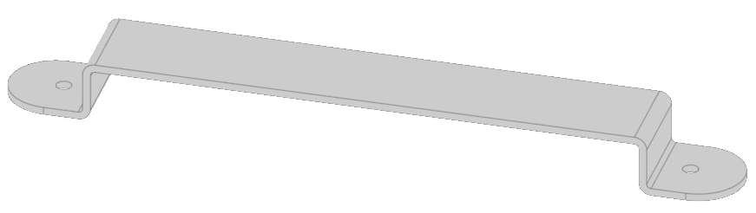
Figure 2.1: Aluminum Handle Prototype

List of Applicable Standards
The following is a list of two standards relevant to the structural subsystem. Both pertain to the insulation and its process of being properly applied to the system in accordance with national rules – ASTM stands for “American Society for Testing and Materials”. This organization is especially pertinent to Thermocline’s system, ensuring the team’s fabrication process, resources, and tools are all efficient, adhere to proper safety, and promote the success of the final product.
- ASTM F1886: “Standard Test Method for Determining Integrity of Seals for Flexible Packaging by Visual Inspection”
- ASTM C633-01: “Standard Test Method for Adhesion or Cohesion Strength of Thermal Spray Coatings”

Analysis
Based on the law of heat conduction, the thickness of insulation is a function of the insulation’s thermal conductivity ($k_{ins}$), surface area ($A_{sur}$), internal temperature ($T_{int}$), external temperature ($T_{ext}$), and the heat transfer rate (${\dot{Q}}_{cod}$) (Equation 1).
${Δx}_{ins}=\frac{k_{ins}A_{sur}(T_{int}-T_{ext})}{{\dot{Q}}_{cod}}$ (1)
In using estimated and expected values for each variable, the minimum insulation needed to maintain a safe-touch temperature of 50ºC during heating is 0.095in (Equation 1).
${Δx}_{ins}=\frac{(0.036\frac{W}{m∙K})(810{in}^{2})({70}^{o}C-{50}^{o}C)}{156W}\left[\frac{0.0254m}{1in}\right]$ (1)
${Δx}_{ins}=0.095in$
The results of this analysis, albeit rudimentary and include numerous underlying variable/value assumptions, provide insight into critical layers of insulation needed throughout the system during heating operations. Cooling will require less insulation to maintain a safe-touch temperature as the temperature-difference between the internals and externals of the chamber will be smaller. These conclusions also assist the design of the chamber regarding the redirection of airflow in order to maintain temperature uniformity, arrangement of components, and the level of safety needed to be present – satisfying defined and ancillary requirements. The insulation design is to include a large factor of safety, with excess amounts of fiberglass insulation material used to protect internal components and hold a touchable external temperature. Ensuring no air gaps and tight seals conforming to the structure will reduce thermal leakage within the system, and uphold the level of safety desired by the team.
A critical analysis needed for the structural subsystem is also the total weight. For this directly influences operator usability and convenience, while also necessitating certain brackets, fixtures, and joints to maintain mechanical stability. Therefore, an analysis was conducted to explore the current best estimate (“CBE”) for the primary structural weight. The team used both property tools and direct measurements from Inventor and Onshape CAD to calculate the volume, converting this to weight given an approximated density of the material. The relevant formula was based on weight ($W$) being a function of density (ρ) and volume (V) (Equation 2). The results can be seen in Table 2.4.
$W=ρV$ (2)
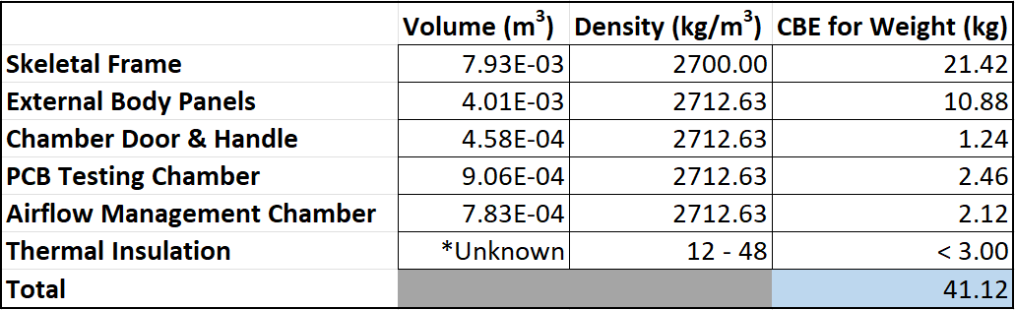
Table 2.4; Current Best Estimate for Structural Weight

Component Design Detail
The design of the structural subsystem primarily consists of the body’s frame, body panels, alongside internal housings and external mechanisms. These constitute the assembly of the materials, components, and design specifications for the structure and its function. When fully assembled, the external view of the product appears to be a solid metal structure, roughly 22(in) by 31(in) at the base, and 24(in) tall. It consists of jointed panels, revealing only a mounted HMI display, chamber door, and the internal access of the PCB testing chamber, as shown in Figure 2.2.
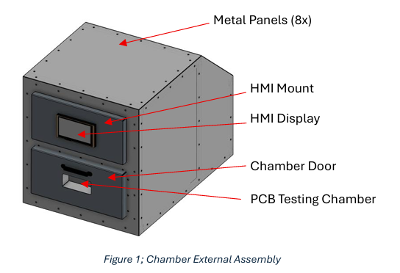
Figure 2.2: Chamber External Assembly
80-20 aluminum-extrusion parts make up the body’s frame – providing the “skeleton” for the system. These are strategically designed to not only support the structural loads and material stresses, but serve as attachment pillars for the external panels and insulation. L-brackets will connect these in the assembly in order to maintain their structural integrity and keep the system properly aligned. Several viewpoints are shown in Figure 2.3.
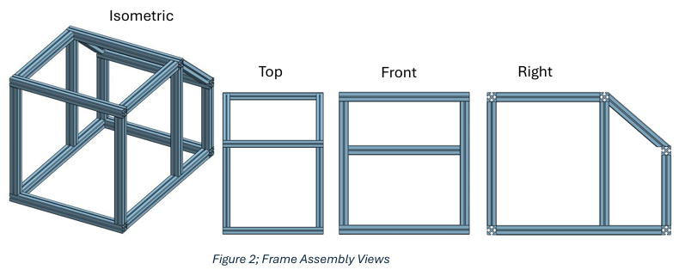Figure 2.3: Frame Assembly Views
The 8 body panels, directly mounted to these frame pieces, consist of 6 external (left and right sides are duplicates) and 1 internal. All will be individually-cut from the Send-Cut-Send manufacturer, and are designed to provide easy installation and removal for necessary maintenance purposes. All panels will have laser-cut holes, allowing screws to mount the panel to the respective frame. Other holes are designed for “rivnuts” that connect to other components of the system; these joints are an integral part of the system, ensuring all structural connections are secure, able to withstand internal stresses caused by mechanical vibration, and can be easily attached to the thin Aluminum pieces which constitute most of the structural frame and body. All panels are shown in Figure 2.4.
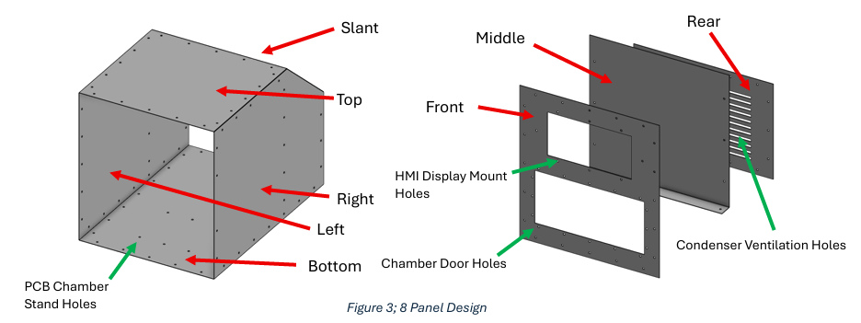Figure 2.4: 8 Panel Design
The PCB testing chamber, mounted to the rear of the front panel, is outlined in Figure 2.5. There are 4 pieces, including 1 top, 1 bottom, and 2 sides. The parts will be made from the same material, and primarily due to the complex shapes, manufactured from Send-Cut-Send. They are designed for simple installation and maintenance. The chamber shall also have a subjacent “stand” serving for structural support and mitigation of vibrations during operation – mounted to the bottom panel.

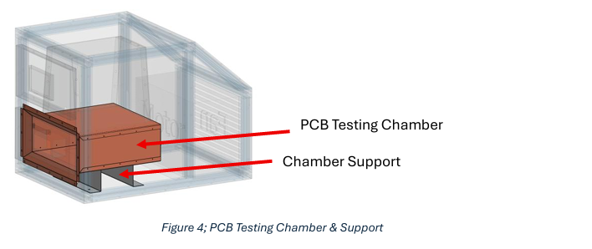Figure 2.5 PCB Testing Chamber & Support
The air management compartment redirects airflow throughout the PCB testing chamber, being mounted to the top, and is outlined in Figure 2.6. The 3-panel design consists of 1 front, 1 rear, and 1 top piece. This allows the respective personnel to have easy access to the internal components, while providing room for the thermal-fluid and electrical components to reach the rest of the system. These pieces will be fabricated with the same material and manufacturer described aforehand.
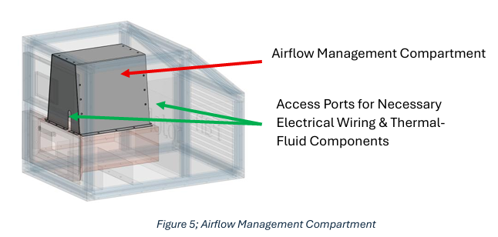Figure 2.6: Airflow Management Compartment
The HMI Display Mount is to be fabricated with the same material and manufacturer, and mounted on the front panel. Its features were designed for aesthetics, ease of HMI-installation, and a proper cavity for all necessary electrical wiring to protrude from the back. The HMI mount is shown in Figure 2.7.
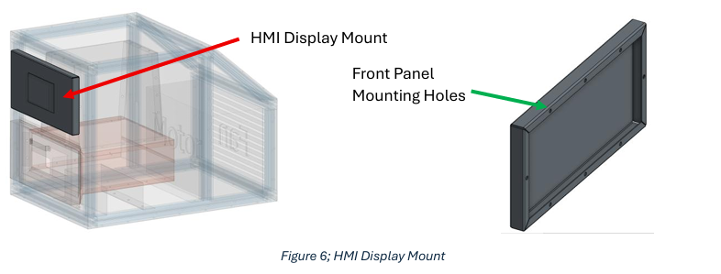
Figure 2.7: HMI Display Mount
The external door, shown in Figure 2.8, is to be made of 3 primary parts, including a front piece, rear piece, and handle. Each is to be fabricated with the same material and manufacturer. The door will be hinged to the front panel, ensuring a smooth opening-mechanism. There shall also be a glass window housed between the front/rear pieces to provide viewing access into the chamber, reducing the need to open the door mid-operation.
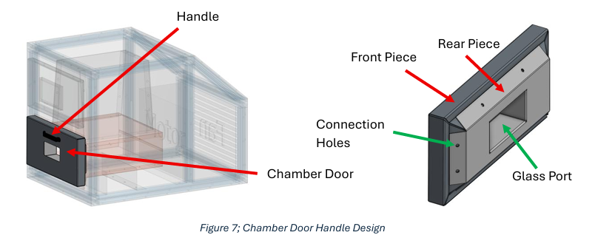Figure 2.8 Chamber Door Handle Design
Last of all, fiberglass insulation fills most of the empty space in the system – within the panels – providing sufficient protection to satisfy the “proper thermal sealing” requirement for both chamber openings and components; this increases human safety, material longevity, and maintains proper system operation.
The structural subsystem, falling under the “mechanical” category of the product, focuses mainly on the intricates of the framework design, and its supporting impact for other subsystems. Its primary purpose is to maintain the integrity, alignment, and stability of itself and other components. Its design is made for efficient connections and organized integration of wiring that ensure a mechanically solid and highly functioning system; the support provides mounting points for fixtures and devices, maintaining positioning, solid connections, and mechanical stability during loading/unloading boards and reliability during PCB testing. It ensures a rigid enclosure for all heating/cooling elements and electronic components, promoting efficient dynamic functioning of other parts. Its secondary purpose is to be designed with proper material usage – ensuring long-lasting quality. A thorough material selection process enables the final structure to withstand thermal heat transfer rates throughout the system, protecting the integrity and performance of other components under natural environmental conditions. During operation, a well-built structural subsystem also reduces mechanical stresses encountered on other components by distributing and dampening loads uniformly, preventing deformation of other internal housings and connections. This ensures other subsystems operate effectively while maintaining safety and precision required for evaluating the performance of the PCB. Overall, the structural subsystem is an integral part of the entire system design, ensuring reliability in itself and other components, alongside high-performance of other subsystems. It is able to satisfy the requirements with a strategic design that accounts for external/internal dimensions (STR-01, STR-02), while also including proper thermal sealing for openings (STR-03) and necessary components (STR-04).

Subsystem: Structural – Thermo-Fluid

System Requirements
Table 3.1: Thermo-Fluid Requirements

System Design

Trade Studies

Proof of concept or feasibility testing

List of Applicable Standards

Analysis

Component Design Detail

Subsystem: Safety

System Requirements
The following section details the Safety Subsystem requirements and their compliance information. Requirements are grouped by category to align with system-level safety goals. Each table provides traceability between the requirement, associated rationale, applicable standards, and planned verification methods for PDR.
Table 4.1: Internal Safety Requirements
Number | Requirement | Rationale | Stand/Source | Verification Method | Status
SAF-01 | The internal surfaces shall be safe for electronics according to ASTM D3874-20 | Ensures internal chamber surfaces do not cause thermal or material degradation of sensitive electronics | ASTM D3874-20 | Test- Measure internal surface temperatures while chamber operates at maximum thermal load | Planned

Table 4.2: External Safety & User-Contact Requirements
Number | Requirement | Rationale | Standard/Source | Verification Method | Status
SAF-02 | External System surfaces shall not exceed the safe-touch temperature of 50°C per ASTM C1055 | Prevents user injury from unsafe contact temperatures during operation | ASTM C1055 | Test – Measure exterior surfaces at thermal steady-state during high temperature operation | Planned
Table 4.3: Operation & Fault-Response Requirements
Number | Requirement | Rationale | Standard/ Source | Verification method | Status
SAF-03 | The system shall be capable of operating in normal environmental conditions of 21°C. | Ensures reliable performance under expected laboratory ambient conditions. | System Environmental Requirements | Analysis/Test - Validate thernal stability and control while operating at 21°C ambient | Planned
SAF-04 | The system shall include a safety measure if internal temperature range or tolerance is exceed | Prevents overheating, thermal runaway, and hazardous internal conditions | System Safety Requirements | Test/Inspection - Induce fault condition and verify that safety mechanism activates as intended | Planned
Table 4.4: Safe-State Requirements
Number | Requirement | Rationale | Standard/Source | Verification Method | Status
SAF-05 | The system shall incorporate a defined “safe-state” that engages during abnormal or unsafe conditions | Ensures chamber transitions to a non-hazardous state to protect users and hardware | System Safety Requirements | Analysis/Test - Simulate fault conditions and verify that the system enters and maintains safe state | Planned

System Design
While safety is a very important subsystem there was many overlaps in the Trade Studies we have done. S0 Although there is no trade study specifically in this section the insulation trade study is very valuable to consider for safety. It will help to determine the most suitable option to keep the chamber a resonable temperature to touch because the insulation will limit the amount of heat loss.

List of Applicable Standards
ASTM D3874-20
ASTM C1005

Analysis
The thermal resistance, R, is a function of the thickness of the insulation, L, divided by the thermal conductivity of the insulation, k. (Equation 4.1)
$$R=\frac{L}{k}$$
$$R=\frac{0.1524m}{\left(0.032\frac{W}{m⋅K}\right)}=4.76$$
$$R=\frac{0.1524m}{\left(0.034\frac{W}{m⋅K}\right)}=4.48$$
Where
L = thickness(m)
K = Conductivity (W/m*K)

I have used 2 different values because in the specifications of this material there was a range so I checked both sides of the spectrum for these values to get a range.

Component Design Detail
The safety subsystem is integrated throughout the entire system rather than being represented by a single physical component. Its purpose is to ensure safe operation of the device under all expected environmental and load conditions by mitigating thermal, structural, electrical, and operational hazards. The safety design relies on coordinated interactions with the Structural, Thermo-Fluid, Electrical Components, and Control System subsystems to maintain safe limits, prevent equipment damage, and protect personnel.

Interface With Structural and Thermo-Fluid Subsystems: Insulation and Safe-Touch Temperature
A primary safety feature is the installation of thermal insulation, which provides a barrier between hot internal components and the external structure. The insulation physically interfaces with the structural subsystem by attaching directly to the interior surfaces of the housing. Structurally, the insulation must comply with thickness, compressive strength, and mounting constraints, ensuring that it does not interfere with internal clearances or cause deformation of panels.
From a safety standpoint, the insulation ensures the external surface temperature remains within safe-touch limits. This prevents burn hazards and reduces the risk of unintentional thermal exposure during handling or maintenance. The thermo-fluid subsystem provides the heating and airflow conditions which determine internal temperatures; the insulation enables this subsystem to operate effectively by limiting heat loss, controlling thermal gradients, and maintaining predictable external temperature profiles. Together, the insulation and thermo-fluid subsystem form a coupled safety barrier that protects users while preserving structural integrity.

Interface With Electrical Components: Current Transformer for Electrical Protection
The safety subsystem also interfaces closely with the electrical components through the inclusion of a current transformer (CT). The CT is used to monitor real-time current draw from critical components. Its primary safety function is to detect abnormal electrical conditions—such as overcurrent, short circuits, or unexpected load spikes—that could generate heat, damage components, or create fire hazards.
Figure 4.1: Current Transformer

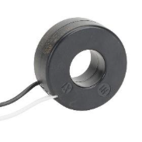
The CT sends continuous current measurements to the electrical subsystem and, more importantly, to the control system. When the sensed current exceeds a predefined safety threshold, the CT enables the system to trigger protective circuitry, initiate controlled shutdown procedures, alert users through system indicators, and prevent overheating in wiring or power electronics. Because electrical faults are often precursors to thermal or structural hazards, the CT acts as a key interface point linking electrical safety to the overall system health. It ensures compliance with safety limits and provides the data necessary for automated protective actions.

Interface With Control System
The control system integrates all safety data including temperature readings, CT feedback, and environmental monitoring into a unified logic framework. It uses these inputs to enforce safety rules, initiate alarms, and command subsystem shutdowns when necessary. This makes the control system the enforcement mechanism for the safety subsystem’s requirements.

Subsystem: Electrical Components

System Requirements
The electrical components subsystem contains six requirements, including rules dictated by NEC (National Electrical Code) and UL (Underwriters Laboratories), as well as requirements per the project.
Table 5.1: Electrical Components Requirements
Number | Requirement | Rationale | Standard/Source | Verification Method | Status
COM-01 | The PCB shall be operatable while temperature is controlled | Ensures the electronics under test can function reliably during thermal testing without interruption or damage due to active temperature control | System ConOps; Functional Performance Requirement | Measure (Demonstration) | Planned
COM-02 | System will adhere to NEC rules on grounding according to Article 250 | Proper grounding reduces the risk of electric shock, equipment damage, and fire hazards, ensuring safe operation for users and equipment | NEC Article 250 | Inspection | Planned
COM-03 | System will adhere to NEC rules on appropriate fuses and load wire sizes | Correct fuse ratings and conductor sizing pretext the system from overcurrent conditions and prevent overheating or fire. | NEC (Overcurrent Protection and Conductor Sizing Requirements) | Inspection | Planned
COM-04 | System will adhere to UL 61010 for test and measurement equipment | Compliance ensures the system meets recognized safety requirements for laboratory and test equipment operation | UL 61010 | Inspection | Planned
COM-05 | The sensors shall be properly rated to withstand internal environment conditions. | Ensures sensor accuracy, reliability, and longevity when exposed to expected temperature ranges inside the chamber | Manufacturer Datasheets; System Environmental Requirements | Inspection | Planned
COM-06 | The system shall support PC connection for datalogging | Enables data collection, analysis, traceability, and verification of system performance during testing | System ConOps; Data Logging Requirements | Inspection | Planned

System Design

Trade Studies
The primary trade study for this subsystem is the heating element. A trade study was conducted via four possible options:
Table 5.2: Heating Trade Studies
 | Resistive | Inductive | Convection | Reversible Heat
Description | Current Passes through a resistive element which converts energy into heat through the element’s resistance | A quickly alternating magnetic field that induces eddy currents | Transfers heat through circulating air/fluid, heated by resistive elements. | Add a reversible heat valve to allow recycling heat from the thermal hot side for use in heating.
Price | ~$100 | ~$800 | ~$600 | ~$500
Risk | Overheating/fire hazard | Electromagnetic Interference (EMI)/ magnetic fields | Temperature non-uniformity/runaway airflow heating | Adds failure points to the thermal system, risks overheating the oil.
Proof of concept or feasibility testing
For testing, the relays with the flyback protection were breadboarded to ensure that the design worked as is intended.

List of Applicable Standards
IPC-2152
Analysis
To calculate the proper trace width when designing the PCB, four equations were used:
Current Carrying Capacity, where I is the allowable current, k=0.048 for external layers, is the allowable temperature rise, and A is the trace cross-sectional area (width * copper thickness).
$I_{cc}=k⋅{\left(ΔT\right)}^{0.044}⋅A^{0.75}$ (1)
Trace Width, where W is the required trace width, and t is the copper thickness.
$W=\frac{A}{t}$ (2)
Trace Resistance Analysis, where R, is the trace resistance. Ρ is the resistivity of copper $1.72⋅{10}^{-8}Ω⋅m$, L is the trace length, t is the copper thickness, and W is the trace width.
$R=p\left(\frac{L}{t⋅W}\right)$ (3)
Trace Heating/Performance Margin, where ΔT is the temperature rise of the trace and, I is the current through the trace.
$ΔT=0.024⋅I^{1.6}$ (4)
The power traces supplying the relay coil and fans were sized using IPC-2152 (Institution for Interconnecting and Packaging Integrated Circuits) current carrying capacity guidelines. Equation 1 provides the trace current limit as a function of copper cross-sectional area and allowable temperature rise. An allowable temperature rise of ΔT= 10°C is reasonable as the thermal chamber operates over a wide temperature range (-40°C to 85°C), this also ensures that at the extreme case (85°C), the copper, solder joints, and connector plastics remain under 95°C, which is within IPC guidelines material limits and helps to improve longevity. The resulting required trace area is now converted to trace width using equation 2 assuming 1oz Copper (0.35 μm thickness). Equation 3 is used to check that the resulting trace width and Voltage drops are acceptable for relays and fan loads. Equation 4 is used to confirm that the expected operating current does not exceed the ΔT margin. Based on these calculations, it was determined that the trace widths should be approximately 8mm, with a maximum current carrying capacity of 12-15 amps.

Component Design Detail
The role of the electrical components subsystem can be understood through the flow chart in Figure 5.1:
Figure 5.1: Electrical Flowchart
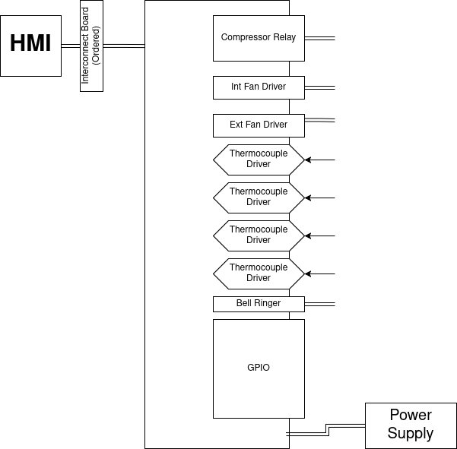

The electrical components subsystem consists of a PCB that provides control and communication throughout the thermal testing chamber. The primary controller is a Raspberry Pi Pico which interfaces with four thermocouple drivers which are used for temperature measurement. The subsystem design, shown in Figure 3, includes relays, a BJT, op-amps, current sense transformers, indicator LEDs, a DHT11 humidity sensor which will be a standalone component, not on the PCB used to measure humidity in the chamber, and an IRM used as the analog-to-digital converter. The interconnect board, shown in Figure #, allows the PCB to talk to the HMI to transmit data to the user.

Figure 5.2: Interconnect board
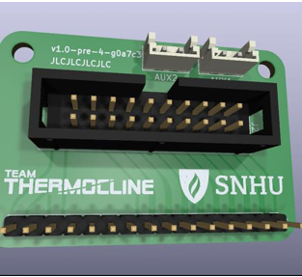

As of most recent updates, the PCB stands as shown:
Figure 5.3: Current PCB Layout
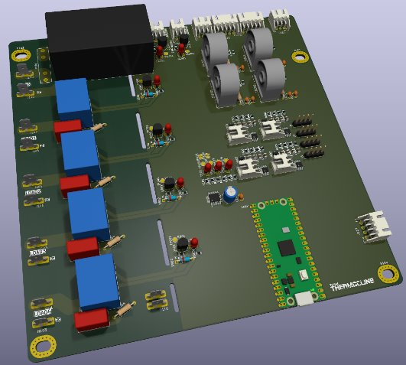
The functional role of the PCB is to monitor the internal temperature of the chamber and communicate that data to the HMI. It continuously reads temperature, humidity, load conditions, and provides the necessary control for the heating and cooling elements.

Subsystem: Control System

System Requirements
Since the software is so broad reaching in the system, many different requirements fall under its roof, including safety, control, power and interfacing.
Table 6.1: Customer/System Requirements
Number | Requirement
CST-1.1 | The system shall include a Human Machine Interface (HMI) for the control system
CST-1.2 | The system shall include separate operating/control modes.
Table 6.2: Control System Requirements (Part A)
Number | Requirement | Rationale | Standard/Source | Verification Method | Status
COM-06 | The system shall support Personal Computer (PC) connection for datalogging | Enables users to collect, store, and analyze test data for performance verification, traceabilitiy, and reporting purposes | System ConOps | Inspection | Planned
CON-01 | The system shall allow local temperature set-point control | Provides users with direct on-site control of chamber temperature to support setup, calibration, and manual testing operations | System ConOps | Test | Planned
CON-02 | The system shall allow remote temperature setpoint control | Allows users to control chamber temperature remotely, iimproving usability, safety, and operatoinal flexibility during testing | System ConOps | Test | Planned
CON-04 | The system shall prohibit thermal control when teh chamber door is open | Prevents unsafe operating conditions, reduces risk of user injury, and protects hardware from unintended thermal exposure | System ConOps | Demonstration | Planned
CON-05 | The system shall prohibit thermal control when a user is handling the Printed Circuit Board (PCB) | Ensures user safety and prevents damage to the PCB by disabling thermal control during direct user interaction | UL 61010 | Demonstration | Planned
CON-06 | The system shall log temperature data | Allows verification of system performance over time and supports post-test analysis, troubleshooting, and documentation | System ConOps | Test | Planned

System Design

Trade Studies

Screen Selection
To meet requirements CST:1.1, SAF:04 and CON:01, the HMI for the systems hall need to provide for both graphics and output, as well as numerical and configuration input.

Table 6.3: Control System Requirements (Part B)
Number | Requirement | Rationale | Standard/Source | Verification Method | Status
CON-07 | The system shall log humidity data | Enables monitoring and verification of environmental conditions that may affect PCB | System ConOps | Test | Planned
CON-08 | The system shall log faults for safety measures | Provides traceability of safely-realted events, supports troubleshooting, and enables verification of proper safety subsystem operation. | System ConOps | Measure | Planned
CON-09 | The system shall have a “shutdown” state | Ensures the system can be placed into a safe condition to protect users and hardware during faults, maintenance, ir emergency conditions | UL 61010 | Demonstration | Planned
CON-10 | The system shall have a “standby” mode | Allows the system to remain powered while minimizing active thermal control, improving safety, readiness, and energy efficiency | System ConOps | Demonstration | Planned
CON-11 | The system shall have a normal operating “start” mode | Establishes a controlled and repeatable transition into normal operation, reducing the risk of unsafe or unintended system behavior | System ConOps | Demonstration | Planned
CON-12 | The system shall allow for manual switching between modes | Provides user control and flexibiility during testing, setup, and troubleshooting while maintaining defined system states | System ConOps | Demonstration | Planned

No requirement mandates that the HMI be part of the machine. Therefore, we could satisfy the requirements by using off-board or external computer control. We considered this alternative in our trade study in Table 5. We quickly decided through the trade study that the most desirable HMI option would be something built into the machine itself, and among those two options, using a low-level interface was the most desirable and thus the selection we went with. We experimented with a few models and settled on purchased one for testing. As part of our initial verification experimented with a CrowPanel HMI screen “7 Inch HMI Touch Display- 800x480 LCD for ESP32/Arduino/LVGL”, 2023 shown in Figure 1. The screen is programmable in C and uses Light and Versatile Graphics Library (LVGL) for the Graphical User Interface (GUI). Our initial GUI design allows the major operating modes, configuration, and calibration to be separated by tabs along the top bar, with buttons in the center and live status, error, and safety warnings below Figure 6.1.
Table 6.4: Screen Selection Trade Study
 | External Computer | LVGL UI | Internal Computer
Boot Time | N/A | Fast | Slow
Size | External device required | Small (under 7”) | Medium to Large (Over 7”)
Estimated ease of use | Low, WiIl require at least setting up site or software on user’s computer | Medium, all controls integrated and available quickly. LVGL may make animations, tooltips and other graphics somewhat basic | High, Full sized UI with as much complexity you like
Ease of integration | High, we don't worry about integration system-side. Push all the work off to software on a PC that isn't ours | Medium, more work on our end. Installation of a screen on the machine and simple graphics | High, we mut manage whole Operating Systems (OS) and graphics stack, as well as the graphics and control underneath
Ease if programming | High, use anything we like | Medium (embedded C/C++) | Medium, graphics are as easy as with an external machine but we must also manage the single board inside as well
Choosing an MCU was a similar process to choosing a screen. Both are crucial parts of the software stack as the controller and display (Table 6 and Table 7) are what will allow the software to run at all. Our trade study took into account how easy it would be to integrate and use the MCU, but also what safety features were offered, what support was available and how expensive it would be to re-tool or replace. In the end, we selected using the RP2040. Having a solid core with good safety systems and easy integration was the most important and met the requirements best.
Figure 6.1: CrowPanel 7.0 ESP32
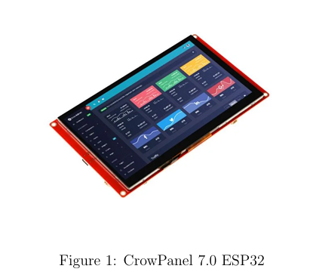

Figure 6.2: Thermocline GUI Prototype, LVGL block
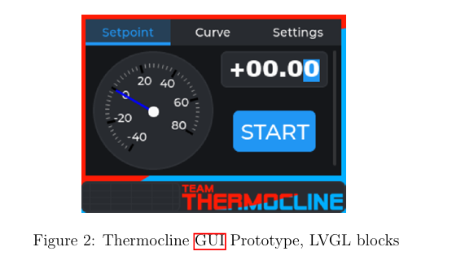

State Machine
A good portion of our design centers around the safety and discrete modes the system can operate in. This is one of the reasons supporting a good Real-Time Operating System (RTOS) was so critical in our selection of an MCU (Table 6.5 and Table 6.6). To this end, our system has several modes, all of which have safety background tasks, control systems tasks, user interface tasks and other functions dependant on the mode you’re in or the mode you’re transitioning to.
Table 6.5: MCU Trade Study (Part A)
Criteria | CRIO (NI) | RP2040 | Arduino (AVR) | Arduino (SAMD) | ESP32
Cost | Very High $2,500 | Very Low <$40 | Low ~ $40 | Very Low < $40 | Very Low < $40
Integration | Low, LabView might be easier to develop on but harder to port (and meet Req COM:06) | Very easy, Integration with python, JavaScript Object Notation (JSON) and Universal Serial Bus (USB) | Easy, Integration over serial | Very easy, full USB stack, python, JSON | Easy, integration over serial
Safety Features | Physical hardware safety features like Electromagnetic Interference (EMI) Electrostatic Discharge (ESD) but limited software ones | Hardware watchdogs, Memory debugging, EMI/ESD | Hardware watchdogs, EMI/ESD | Hardware watchdogs, Memory debugging | Hardware watchdogs, Memory debugging
Figure 3 is a flowchart detailing each state the machine can be in. The primary states are:
- Power-On Self-Test (POST): Power on and self test
- Safe Mode: Safe return mode where the suer can examine an error or reset to a known state with all functions in idle or disabled
- Standby: Default standby mode, await user input and allow to move to any other mode
- Configure: Configure the system, make adjustments and view information before or after use
- Follow Curve: Follow a curve, change the chamber setpoint automatically according toa a script, curve or chart
- Follow Setpoint: Follow a setpoint, change the chamber setpoint to a specific value and hold there.
Table 6.6: MCU Trade Study (Part B)
Criteria | CRIO (NI) | RP2040 | Arduino (AVR) | Arduino (SAMD) | ESP32
RTOS | Yes (But only NI Linuz RT) | Yes (any) | No | YEs (Zephyr and Free Real-Time Operating System (FreeRTOS)) | Yes (FreeRTOS)
Support | Yes (Via NI) | Yes (Most Vendors, RPi, Adafruit) | No (Phasing out) | No (Obscure) | Yes (Some vendors, Esprissif, Adafruit)
Input/Output | Good, Expandable Digital Analog Converter (DAC) and analog-to-digital converter (ADC) operations (at a price) | Good, great General Purpose Input/Output (GPIO) and Programmable Input/Output (PIO) system, only a limited set of analog pins. | Limited poor resolution ADC and limited pin counts and specialized pins | Good, robust ADC and many GPIO on most chips | Good, passable ADC pin counts for most models

Figure 6.3: Thermocline State Machine
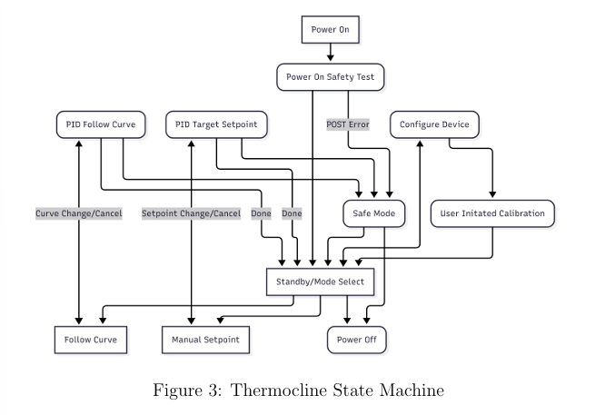
We don’t want to reinvent the wheel; an RTOS on a microcontroller is a common and well-understood task management solution. We chose to use FreeRTOS (“FreeRTOS™- FreeRTOS™”, n.d.) for our system as it allows for easy task creation and management. Tasks will be structured to run on a priority system, where tasks that are checking for safety conditions (such as overtemperature, interlocks, overcurrent, undervoltage, etc.) will preempt other tasks running, or cancel them entirely. This RTOS operation also allows ”background” tasks to run periodically, and perform low-priority items such as updating the display, syncing the time, saving the data.

Figure 6.4: Overview of Task State Management
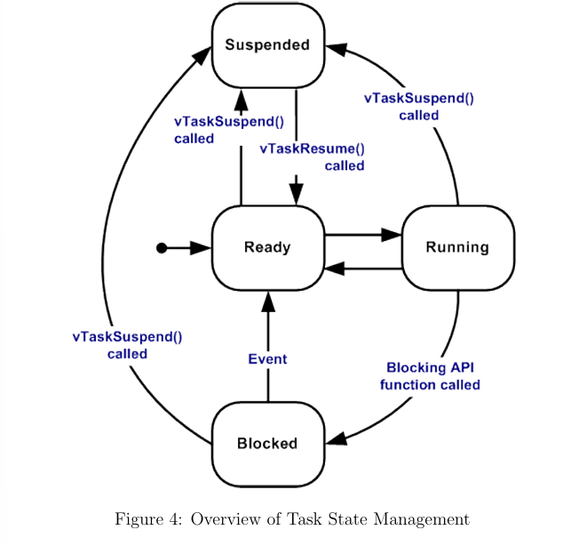
Proof of concept or feasibility testing

List of Applicable Standards

Analysis

Component Design Detail

Intercommunications
The central software controller stack will include both the built in screen, as well as a potential customer computer. To simplify the amount of work we need to as programmers, and the work the system needs to do in computation, the interconnect language will be the same for both. JSON is a common language for intercommunication between systems, and is a good fit for our needs. By encapsulating the data in JSON objects, we can easily send and receive data between one or more systems, as well as assign types, instructions and names to each packet. Such packets may look like Figure 6.5.
Figure 6.5 Example JSON Packet
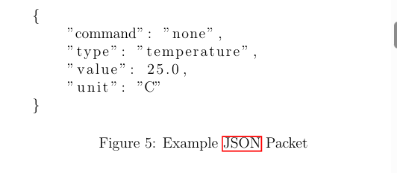

Sensors and Inputs
Computers don’t come with an awareness of their environment so we need to integrate our own. The implementation of which is largely an electrical one, but what we do with those sensors is all in software. There are two main responsibilities turned over to the software, one is actually reading the data and reacting in a timely manner, the other is pro cessing, filtering and presenting the data. One consideration is under- or oversampling. The analog system on our control board will provide as much data as we need, but once we sample it we could be undersampling and alias ing noise. The mitigation of this example can be found in subsection 6.1. For the storage and presentation of the data, we need to consider what rate is necessary for the storage and what rate is appropriate for the pre sentation. The customer may prefer to see a significant resolution in their saved data, but what is shown on the screen may not benefit from a very high update rate. In fact, oversampling could make the screen flicker or look sluggish. The software will balance what data it sends and at what rate, and allow different rates internally.

Drivers and Outputs
The most critical job of the software is at the very end, the end-effector. The product of the control system is to set, unset and toggle various relays, drivers and devices that will do meaningful and potentially dangerous work. Relays have a finite lifespan, arcing across the contacts as well as me chanical wear from cycles will affect their life and the performance of their switches. The software must self-regulate and prevent overuse of the relays. In addition, there are many more loads controllable by the system than the power budget allows for. The software will need to never exceed the power budget and it must keep track of which loads are running and not cycle incompatible loads on at the same time.
Figure 6.6: Example of electrical arcing across relay contacts. Source: Wikipedia
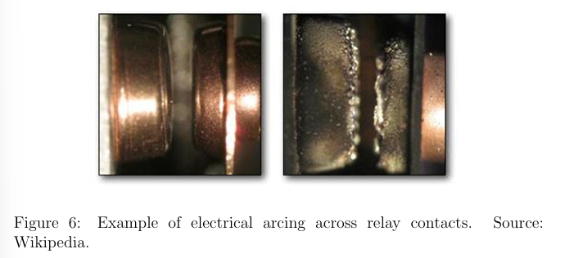

Risks and Mitigation
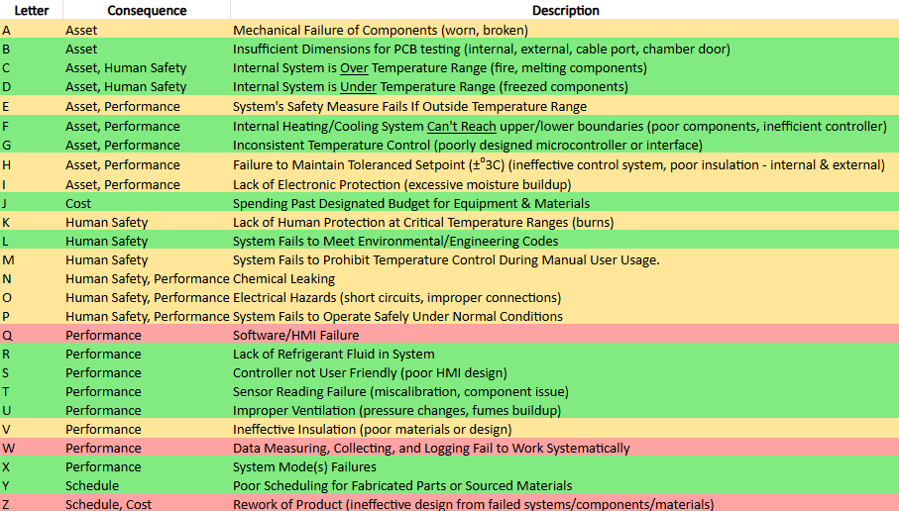
  - Table 7.1: Risk Matrix

  - 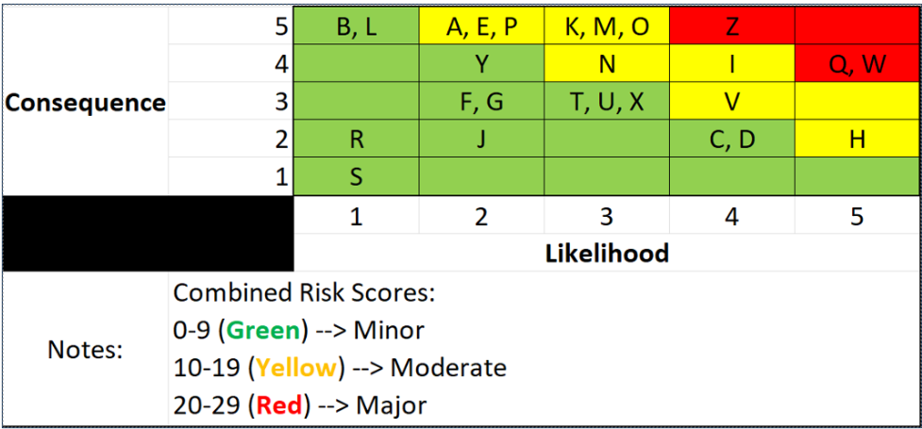Figure 7.2: Risk Vs. Likelihood
  - 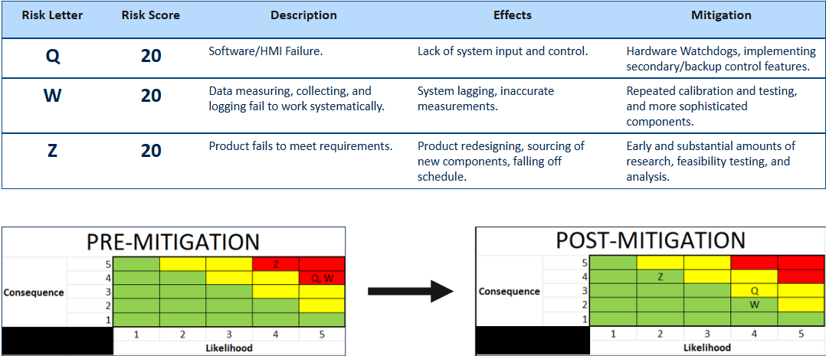Figure 7.3: Most severe risks and mitigations.
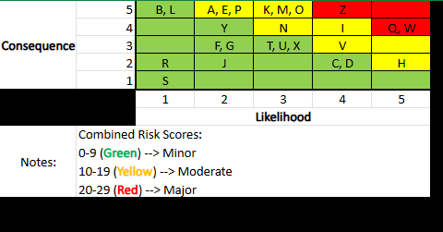

Verification Matrix
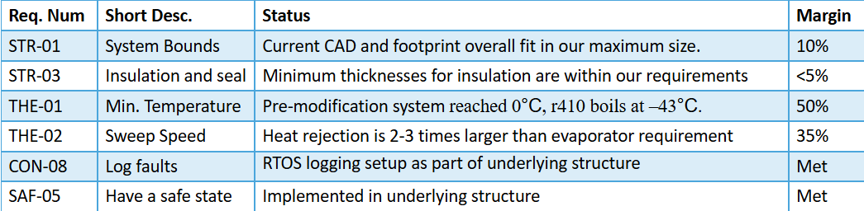Table 8.1: Verification Matrix

Design Considerations

Global Considerations
The system design reflects awareness of global impacts related to material sourcing, manufacturing practices, and energy usage. Aluminum alloys were selected for structural components due to their abundance, recyclability, and relatively low environmental burden. Manufacturing methods were chosen to minimize material waste and promote responsible supply chain practices. Energy efficiency was also considered across thermal control, insulation, and software logic to reduce overall power consumption in alignment with global sustainability goals.

Cultural and Social Considerations
While the system does not directly interface with culturally sensitive applications, its design emphasizes universal usability and accessibility. The chamber is ergonomically designed for ease of operation, with dimensions and interfaces that accommodate a broad range of users. Safety indicators, warnings, and operational cues rely on intuitive symbols and clear visual feedback rather than language-specific instructions, reducing cultural and language barriers. These choices promote safe and inclusive interaction in diverse laboratory environments.

Public Health, Safety, and Welfare Considerations
Public health and safety are central to the system design. Structural materials and insulation prevent hazardous external temperatures and eliminate sharp edges or unsafe protrusions. Electrical safety is ensured through proper grounding, fusing, relay isolation, and PCB trace sizing in accordance with industry standards. Temperature and current sensors, combined with automated Safety Mode logic, prevent runaway heating, electrical faults, and unsafe operating conditions. Interlocks disable thermal control during unsafe states, protecting users, equipment, and the surrounding environment. These measures fulfill ethical responsibilities to safeguard users and the public.

Economic Considerations
Economic efficiency was balanced with safety, reliability, and performance. The use of repeated structural components reduces fabrication and assembly costs. Material selections were optimized to provide durability and long service life, minimizing maintenance and replacement expenses. Cost-effective electrical protection components prevent catastrophic failures and reduce downtime. Energy-efficient insulation and control logic further reduce operational costs, resulting in a system that provides strong long-term value and return on investment.

Environmental Considerations
Environmental impact was addressed through sustainable material selection, energy efficiency, and long-term system durability. High-performance insulation minimizes heat loss and reduces power consumption. Control software limits unnecessary operation and reduces energy usage during fault conditions. Structural design minimizes the likelihood of thermal-fluid leakage and reduces waste by extending component lifespan. Together, these design choices reduce environmental impact, conserve resources, and support sustainable engineering practices.

Open Design Issues
- Chassis
- Shocks/Vibration Dampening
- Pre-Final Sheet Metal (Laser Cutter)

Budget

Table 11.1: Itemized Purchased Budget
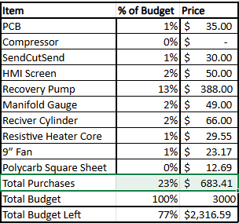
Table 11.2: Overall Budget
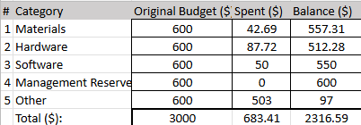

Conclusion
The thermal testing chamber is comprised of 5 major subsystems: structural, thermo-fluid, safety, electrical components, and software. (https://team-thermocline.github.io/)



References
1. OpenAI (2025) ChatGPT v5.0 https://chatgpt.com/chat prompt: “What are some design considerations I should take into account when designing PCB traces?” (with edits)
2. RayMing. (2025, May 14). IPC-2152 Standard: PCB Trace & Via Current Calculator, Free PDF Download, and Design Guidelines https://www.raypcb.com/ipc-2152/
3. HTY. (2025). Copper Trace in PCBs: Everything You Need to Know. https://www.pcbasic.com/blog/copper_trace.html
4. Jhdpcb. (2023, June 19). The Ultimate Guide To PCB Trace Width Calculator https://jhdpcb.com/blog/pcb-trace-width-calculator
5. Trace Resistance Calculator. (2016, April 20). https://www.allaboutcircuits.com/tools/trace resistance-calculator/
6. 7 Inch HMI Touch Display- 800x480 LCD for ESP32/Arduino/LVGL [Sec tion: products]. (2023, June). Retrieved November 20, 2025, from https://www.elecrow.com/esp32-display-7-inch-hmi-display-rgb-tft lcd-touch-screen-support-lvgl.html
7. FreeRTOS™- FreeRTOS™. (n.d.). Retrieved November 20, 2025, from https: //freertos.org
8. Richter, A. (n.d.). The Anatomy of a 3D Printer: Screens. Retrieved Novem ber 20, 2025, from https://www.matterhackers.com/articles/3d printer-anatomy-screen
9. Standard Test Method for determining integrity of seals for flexible packaging by visual inspection. (n.d.). https://store.astm.org/f1886_f1886m-16.html
10. Standard test method for adhesion or cohesion strength of thermal spray coatings. (n.d.). https://store.astm.org/c0633-13r21.html
11. Sendcutsend.com. (2025, October 29). 5052 Aluminum Laser Cutting | SendCutSend. SendCutSend. https://sendcutsend.com/materials/5052-aluminum/#063-bend-specs
12. OpenAI (2025) ChatGPT (GPT-4o) https://chat.openai.com/chat prompt: “How to make this table into a word appropriate table?” with edits
13. ASTM. (2019). ASTM International - Standards Worldwide. Astm.org. https://www.astm.org/
14. https://energycompliance.com.au/what-is-thermal-conductivity-of-different-insulating-materials/?utm
15. Amir, & Amir. (2020, September 17). Thermal properties of insulating materials - Energy Compliance. Energy Compliance. https://energycompliance.com.au/what-is-thermal-conductivity-of-different-insulating-materials/?utm
16. Basso, E. (2024, December 2). The Ribbon 6. AIS Group. https://www.ais-group.com.au/blog/insulation-thermal-conductivity-and-r-value/?utm
17. K-Value, U-Value, R-Value, C-Value. (2017, June 9). Insulation Outlook Magazine. https://insulation.org/io/articles/k-value-u-value-r-value-c-value/?utm

